Wireshark Lab 4-1

202022300317 杨业昶

## Step 1: Capture a Trace.

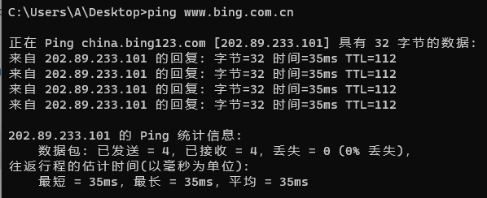

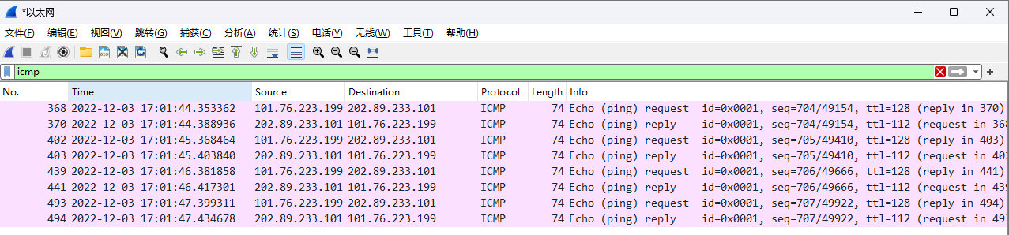

## Step 2: Inspect the Trace

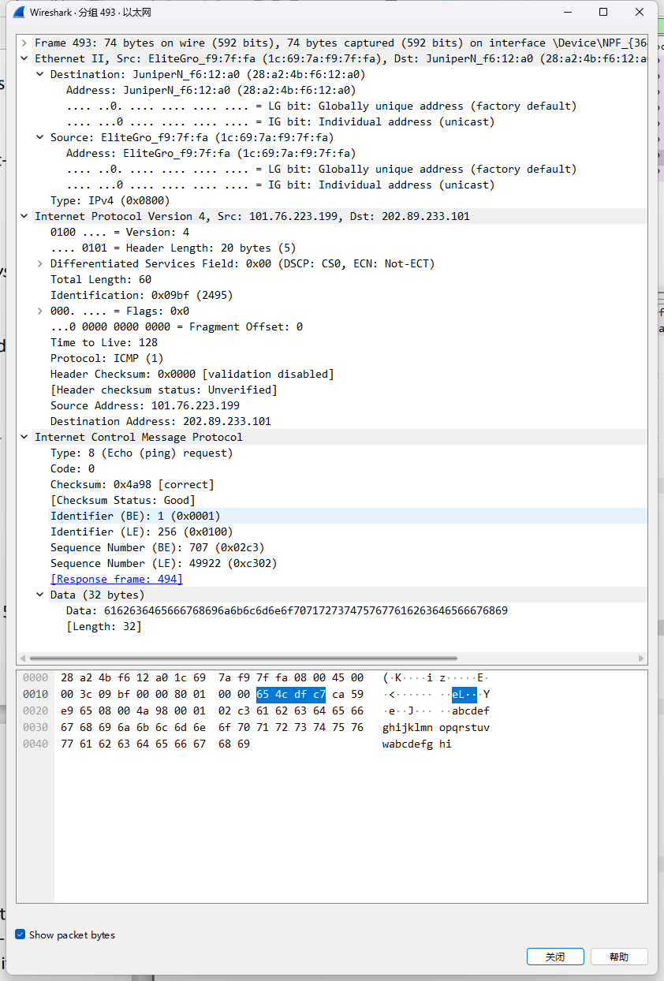

## Step 3: Ethernet Frame Structure



## Step 4: Scope of Ethernet Addresses

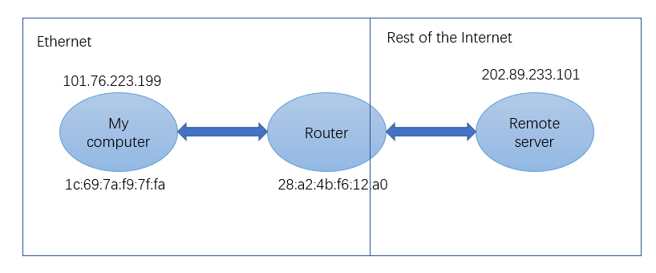

## Step 5: Broadcast Frames

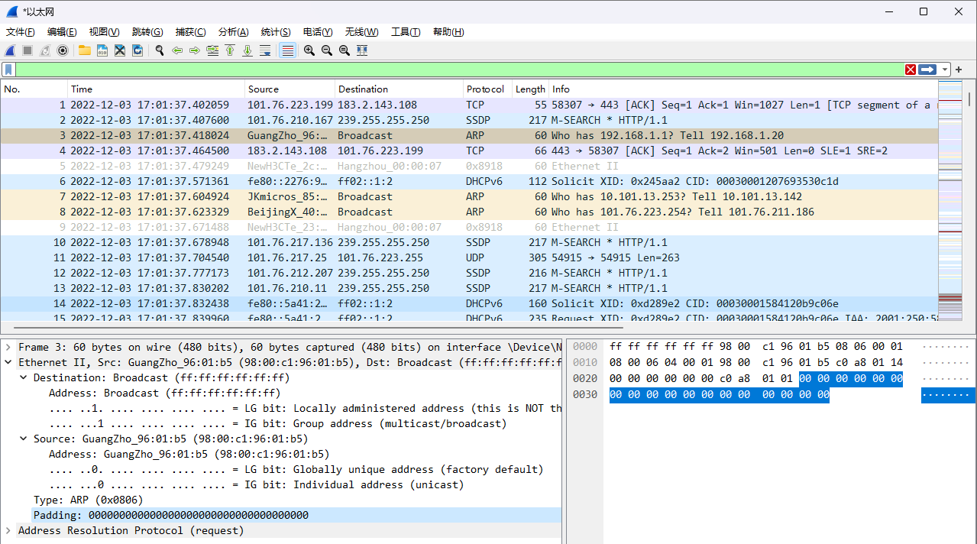

What is the broadcast Ethernet address, written in standard form as Wireshark displays it?

>>> Destination: ff:ff:ff:ff:ff:ff

Which bit of the Ethernet address is used to determine whether it is unicast or multicast/broadcast?

>>> IG bit: Group address